**MAKING A REMOTE CALL TO AN API**

What is a remote call?

Suppose you have are making an application such as tourism application in which the tourists can view the place and find its details such as places to raom about,the hotels and restaurants,the weather and climate,of that area.

So now your application will be called as a Tourism spring boot application.

But in order to get the climate information,restaurants nearby you need to make a remote call to some other api who stores the data about the restaurants in that area.

So our Tourism application is making a remote call to the climate and hotels api.This is called as a remote call.

This can be done:

1.BY Feign Client method

2.By RestTemplate method.

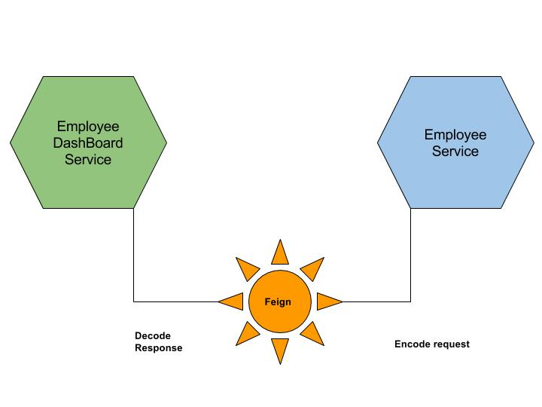

As in the figure above using the feign cliet the employee dashboard service which needs to display the employee details makes a remote call to the employee service sitting aboraod.

**REST TEMPLATE METHOD**

**We are making a post service application.This application will make a remote call to the comments api.Lets see how to proceed.**

COMMENTS SERVICE

POST SERVICE

1.Step 1 is to create an application with a spiring initialize and import it in your ide.

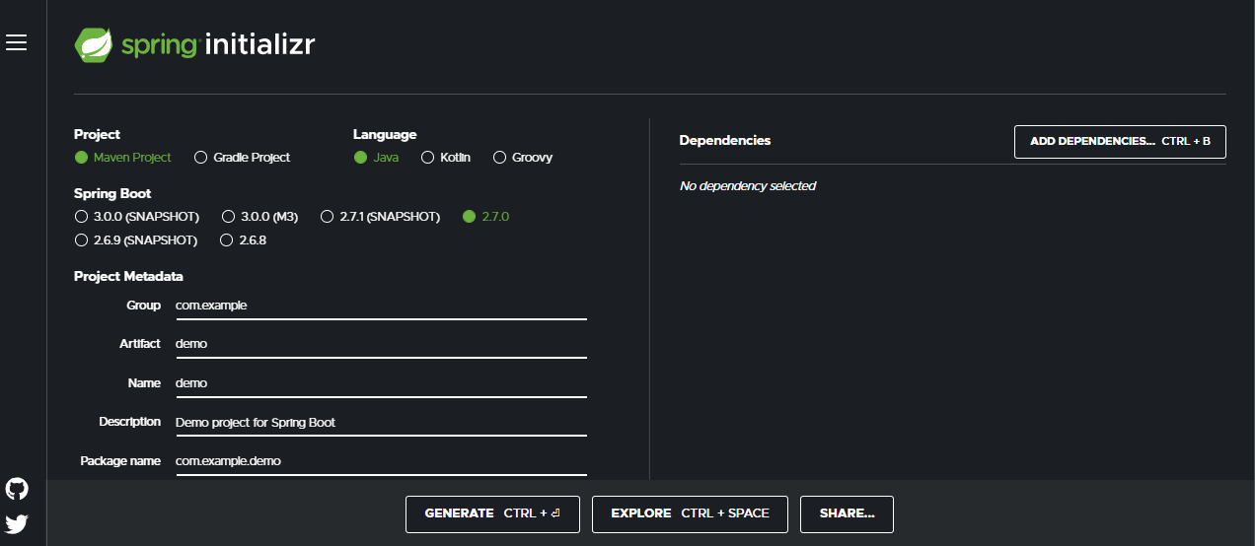

Suppose we have made a post application.

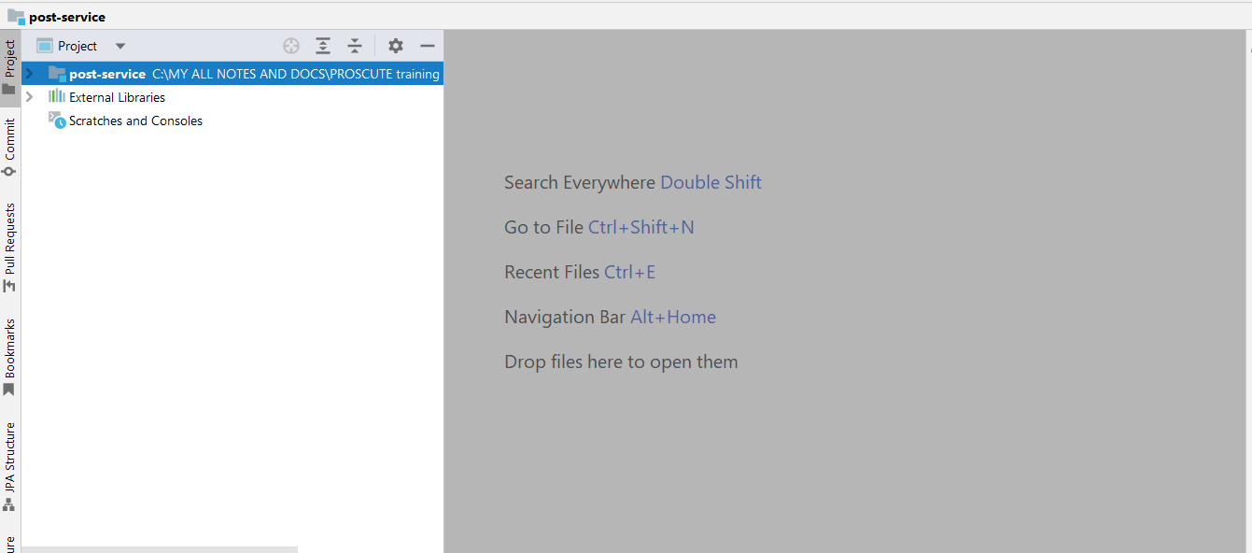

2.Now in the application.properties add the following properties;

**Timeout :**it means the time of connection being made to the url

**Readtime:**it means the time to read the data from the server

**postBaseUrl:**it is the url of the remote comments service

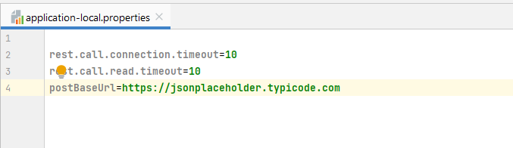

3.Make a controller and a method as shown below:

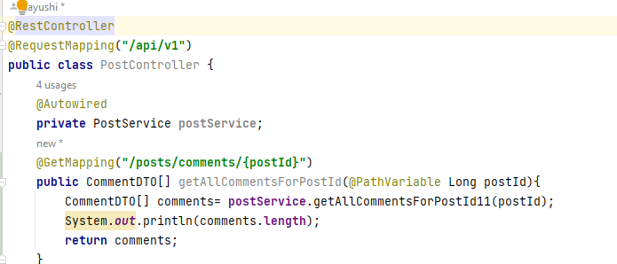

4.Now in the post service do as below:

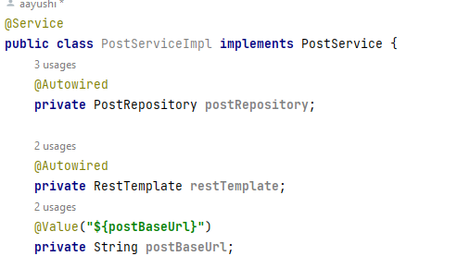

Autowire the RestTemplate in postservice

Make a private url for postBaseUrl

This variable is reading value from the preoperties file by the use of @Value annotation.

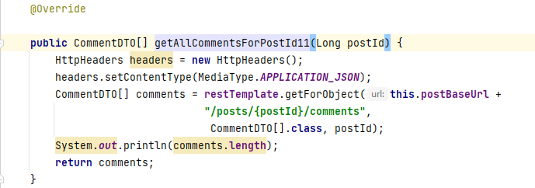

5.Make a method as shown above.

You will receive a comments variable as a result.

6.Now make a call from the postman and you get the result as shown below:

